Group 9

**BRS User Manual**



**User manual**

**Installation:**

# When first installing the system run the installer "Setup.msi".

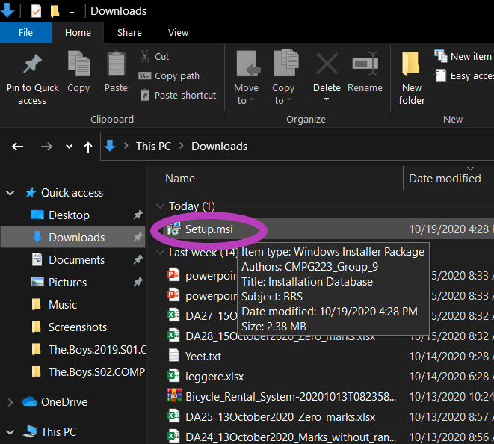

# 2. On the welcome screen there are options to continue or to cancel. "Next" will proceed with the installing process.

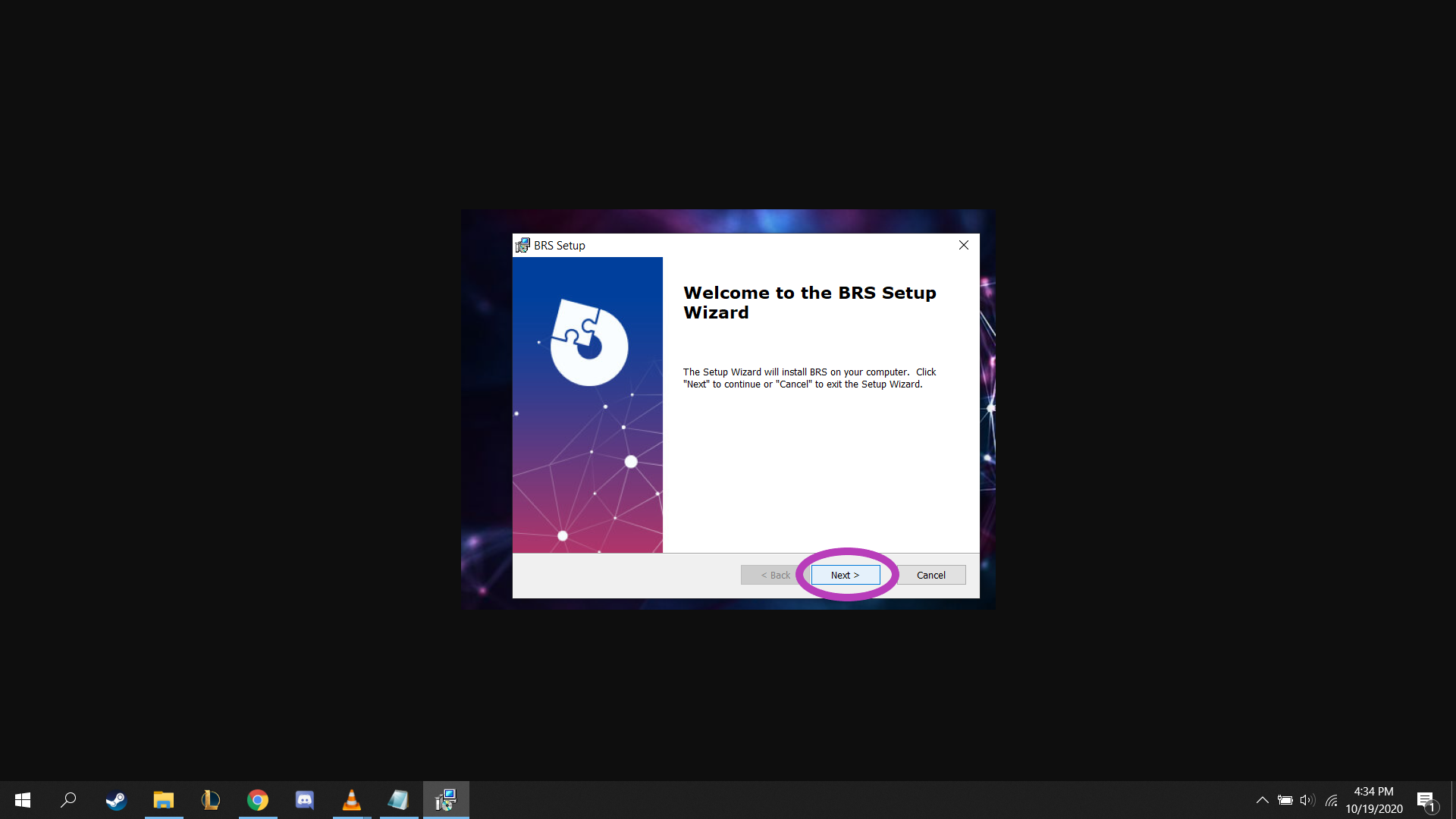

# 3. A window allowing you to select the location you wish to install the system will appear on the screen. The "Browse" button will allow the user to select a folder to install to. Or you may type in the directory in the textbox personally. After this you may select the "Next" button to continue.

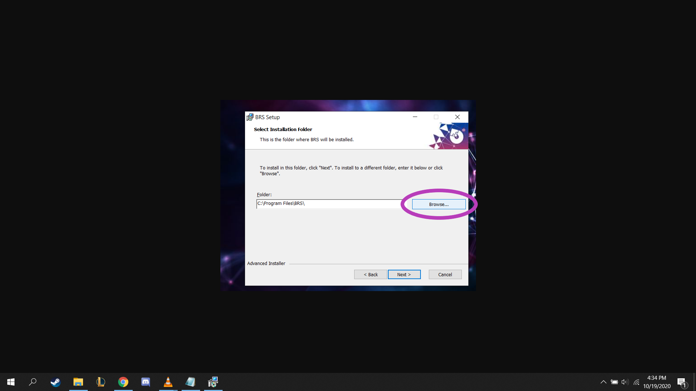

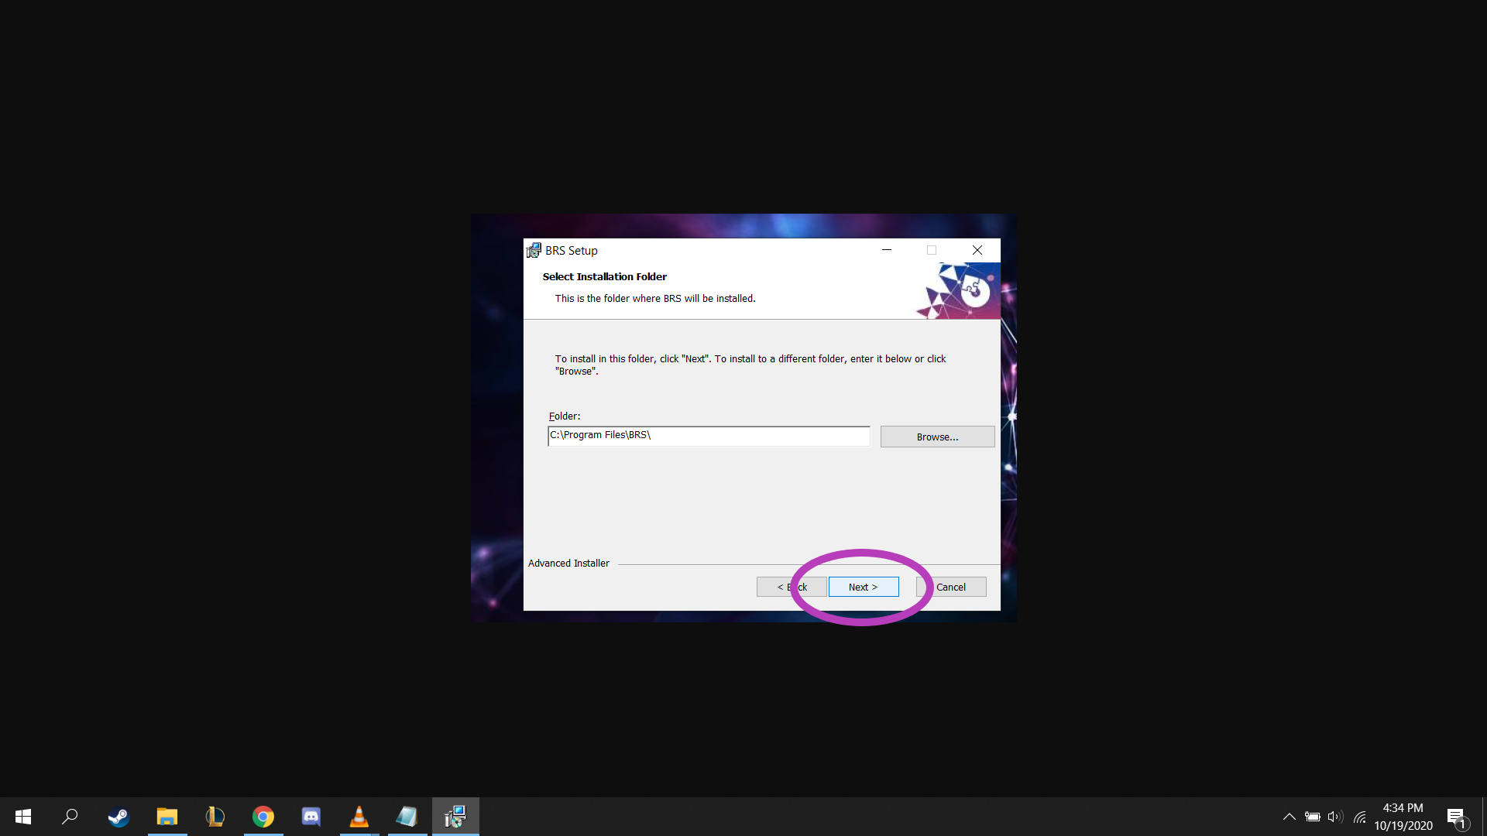

# 4. The next will contain the "Install" button. When clicked a windows pop-up will appear asking for your confirmation. Please select "Yes".

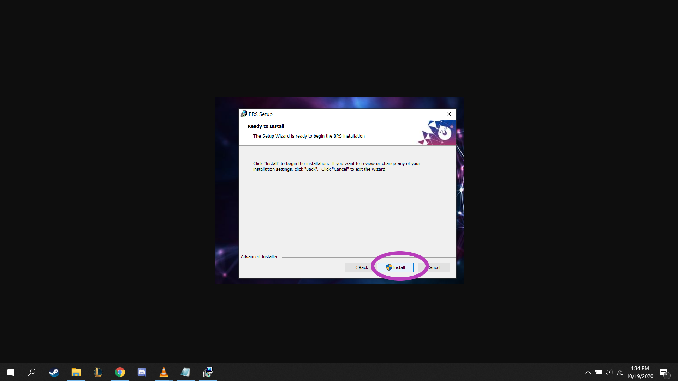

# 5. Please be patient while the installation is taking place. A progress bar will display the current progress of the installation.

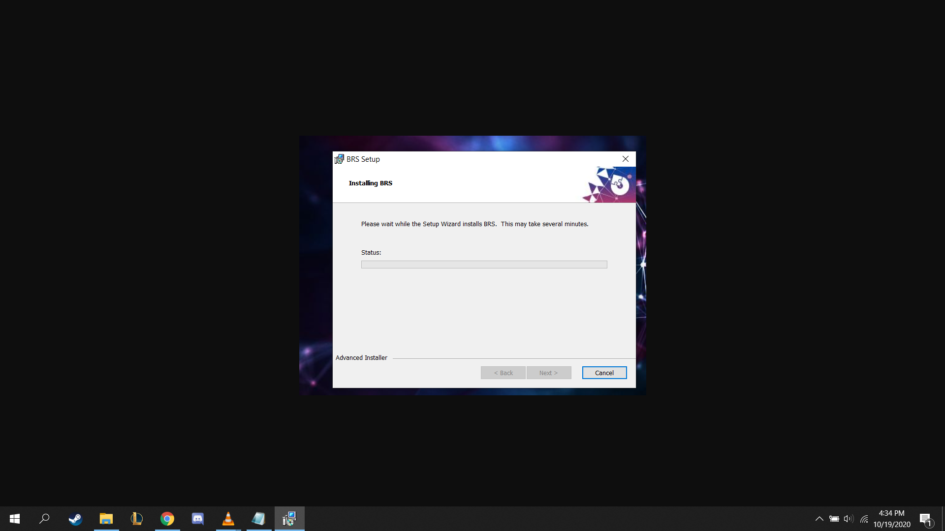

# 6. When the installation is complete a final form will appear. Please select the "Finish" button to close the form.

# 7. A desktop icon will be available on your desktop which will open up the newly installed system for the employee to use.

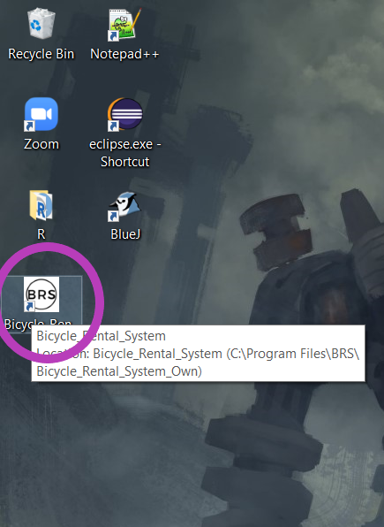

**System Requirements:**

**Processer Speed:** *Minimum:* 1.8GHz *Recommended:* 2.5GHz

**RAM:** *Minimum:* 4GB *Recommended:* 8GB

**Disk Space:** *Minimum:* 100MB *Recommended:* 1GB

**Windows operating system:** *Minimum:* Windows 7 *Recommended:* Windows 10

**Other:**

* Stable internet connection.
* USB ports for an external storage device.